**Sign up Page**

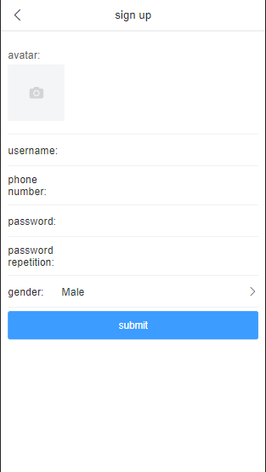

Users can register an account through the sign up interface. Users can upload images to set passwords, gender and more. Users can log in after registration.

**Login Page**

After registration, the user can log in with a username and password.

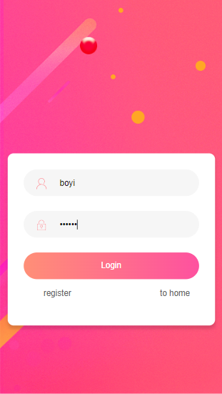

**Home Page**

After the user logs in, the user will enter the Home Page. Users can make reservations and other operations on the main interface.

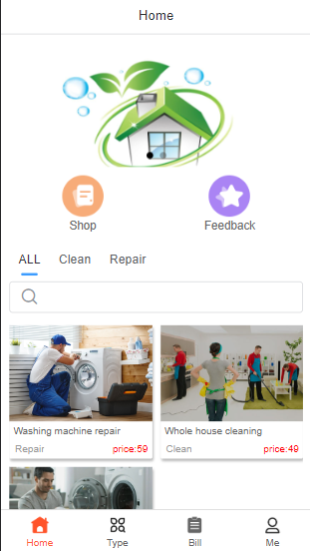

**Shop Page**

There is a Shop button in the upper left corner of the Home page. Users can view service provider information here.

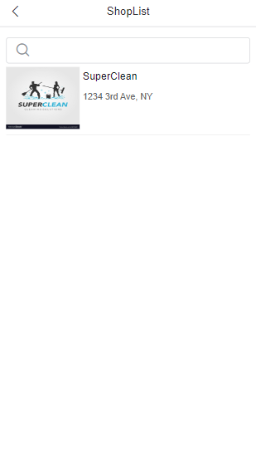

Service Information Page

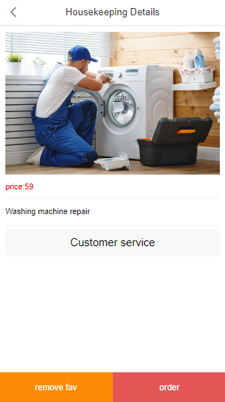

In this interface, you can view the specific information, description and price of the service. Users can book services on this page, and users can add their favorite services to Favs.

**Search Bar**

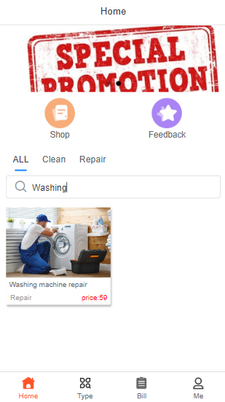

In the later stage of this APP development, there will be a large number of services on the Home Page. So this APP has developed a search bar on the main interface. The search bar facilitates users to search for the services they need. This makes it easy for users to quickly find the services they need.

**Service Classification**

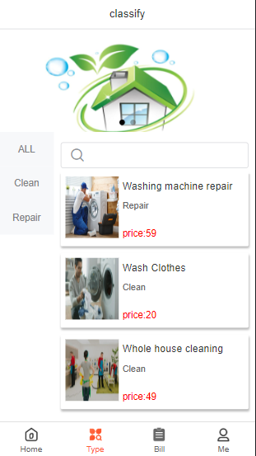

The purpose of categories is the same as that of the search bar. This is to facilitate users to search and view the services they need. In many cases, users need to view all services under the service category for comparison between services. Users find the most cost-effective service for them.

**Order Page**

Users can make service reservations on the order interface. On this page, users need to provide contact information, booking time and some special requirements.

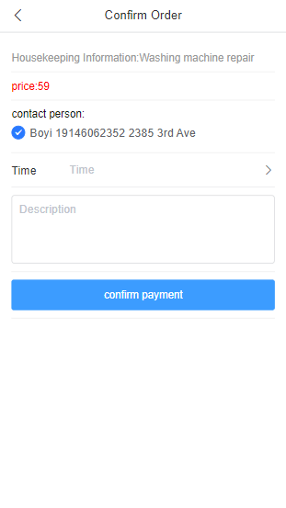

**Order Information**

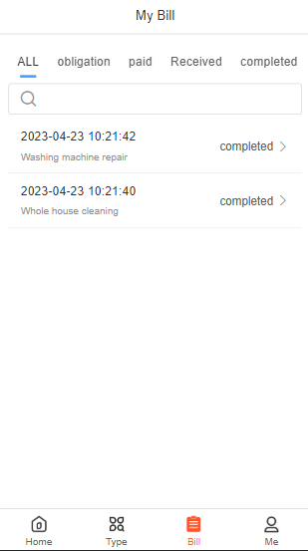

Users can view their reservations, order time, order price, and current order status on this page.

**Order Feedback**

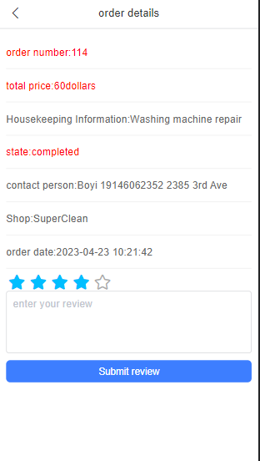

In this interface, users can evaluate service orders through stars, and users can add text comments.

**Personal Information**

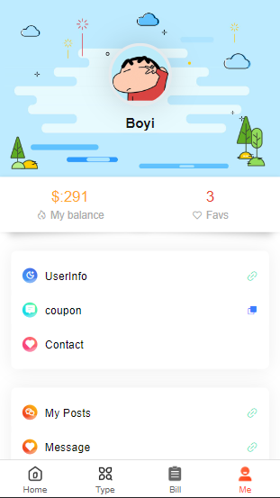

Users can recharge and change personal information and account passwords on the personal information interface.

**Modify Personal Information**

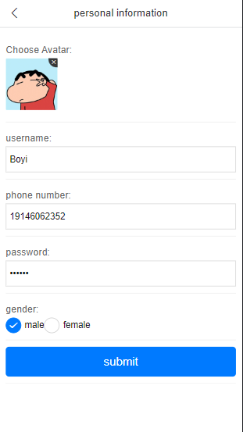

Users can modify phone number, Username, password and gender in this interface.

**Log out**

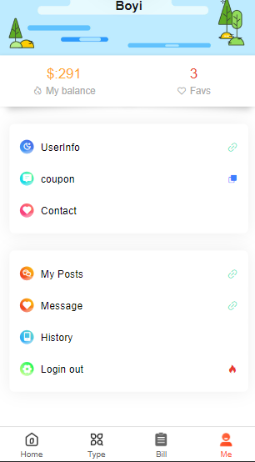

Logout is available at the bottom of the user interface.

**User Information Management**

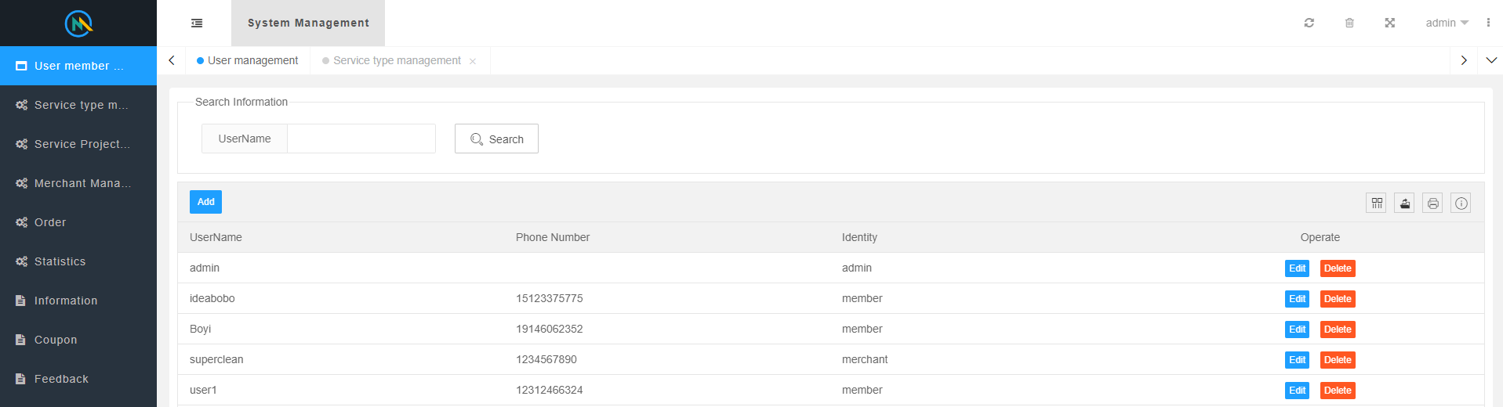

This is the backend administrator interface, where administrators can view user information and modify user information. User accounts can also be deleted or added.

**Service Type Management**

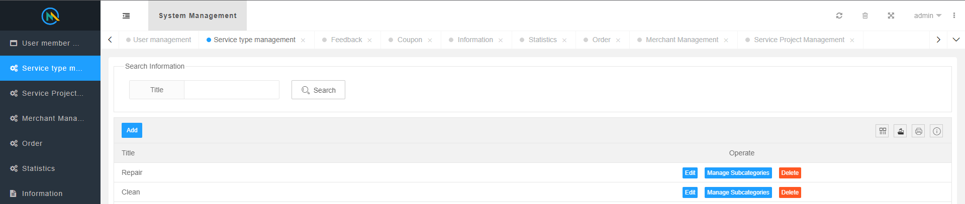

Administrators can manage service types here. This backend corresponds to the category in Figure 4.7. Administrators can add or delete service types.

**Service Management**

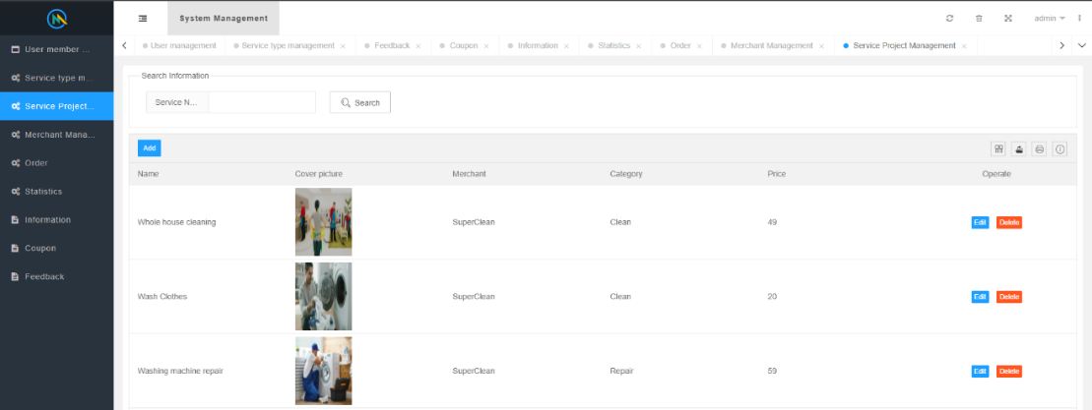

On this page, administrators can manage and review specific services. Administrators have permission to edit and delete these services.

**Merchant Management**

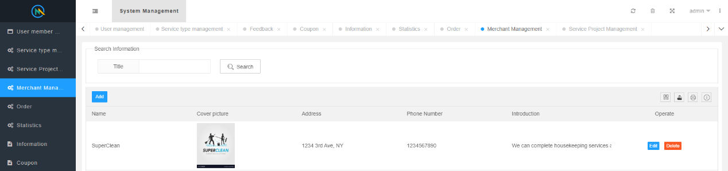

On this page, the administrator can review or edit the specific information of the merchant.

**Order Management**

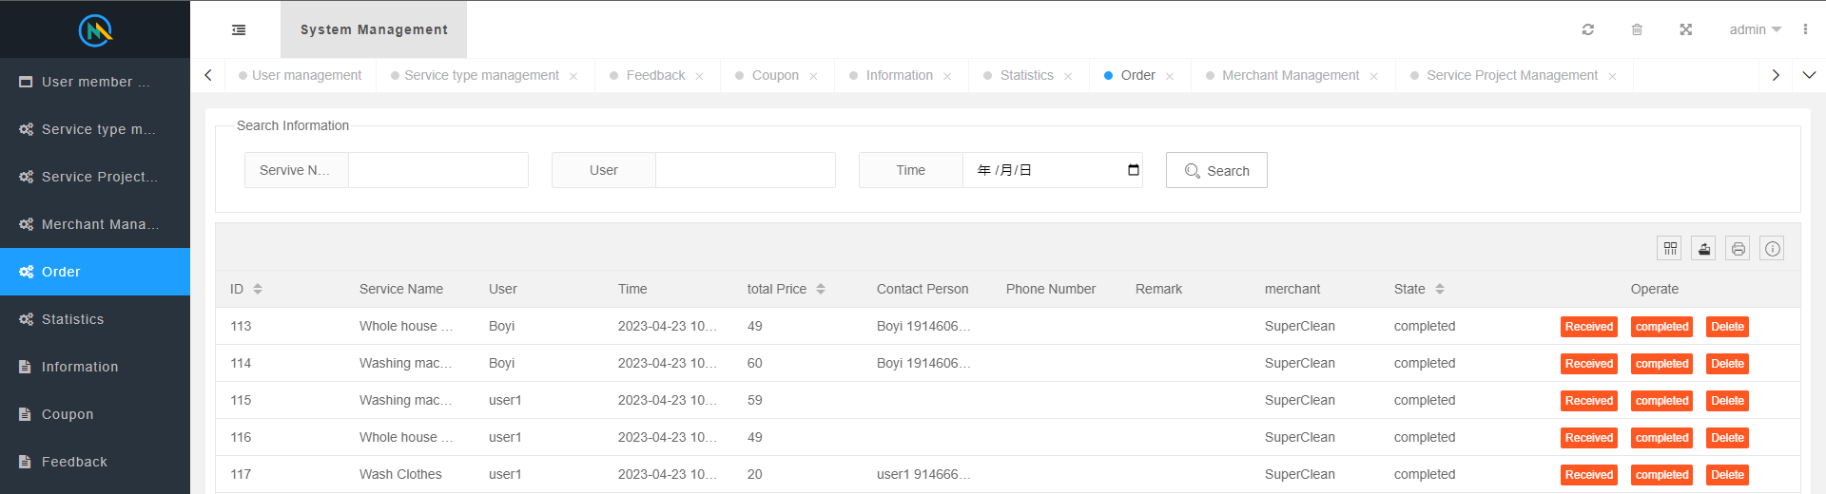

In this backend interface, administrators can manage orders. And change the status of the order according to the progress of the service, pending, completed, evaluated and so on.

**Backend Visualization Data**

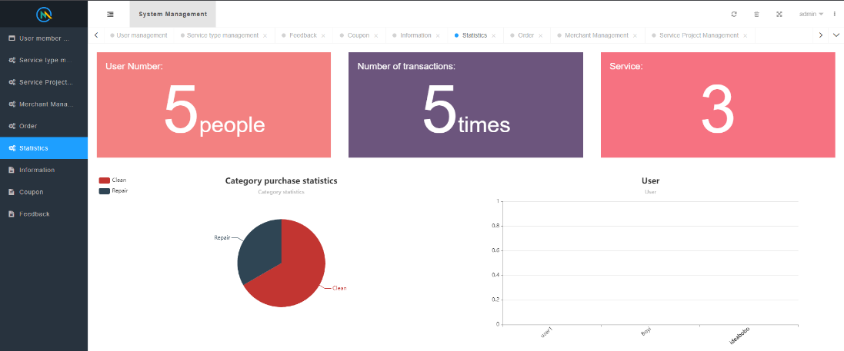

In this interface, the administrator can view the overall data statistics. The administrator can view the number of users, the number of orders and so on. And all the data is visualized. It is convenient for the administrator to view the App as a whole.

**User Feedback Management**

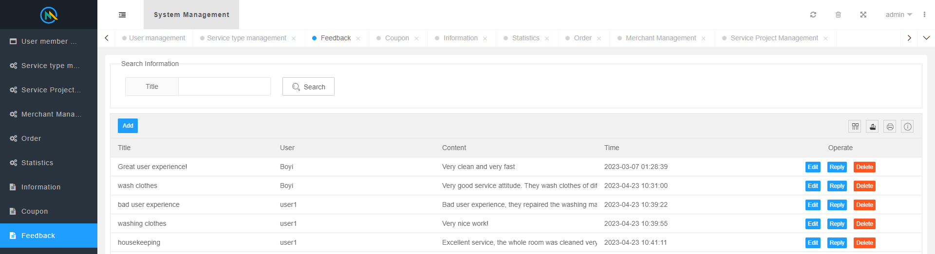

Administrators can view user evaluations of the service on this page. In this way, it is convenient for the administrator to improve the APP and supervise the service quality.